Batch: D2 Roll No.: 25

Experiment / assignment / tutorial No. 6

Grade: AA / AB / BB / BC / CC / CD /DD

Signature of the Staff In-charge with date

TITLE: Array of Structures.

______________________________________________________________________
AIM: Program to declare an array of structure `players` having data members (name, total matches played, best bowling figure). Program should do the following operations using functions.
- Insert Minimum 5 player data in array of structure
- Sort and display this data in descending order of their best bowling figure (if wickets are same then consider less run conceded as priority) and in proper tabular form
- Delete the data for any one player.
- Search for a particular player using its name.

Expected OUTCOME of Experiment:

_____________________________________________________________________
Books/ Journals/ Websites referred:

- Programming in C, second edition, Pradeep Dey and Manas Ghosh, Oxford University Press.
- Programming in ANSI C, fifth edition, E Balagurusamy, Tata McGraw Hill.
- Introduction to programming and problem solving , G. Michael Schneider ,Wiley India edition.
- http://cse.iitkgp.ac.in/~rkumar/pds-vlab/

_____________________________________________________________________

Problem Definition:

Create an array of structure ‘players’ which store information about multiple players having different data members such as name, total matches played, best bowling figure.
Program should read choice from the user and perform following function:

Choice 1: Insert data in array of structure.
Choice 2: Sort and Display
Choice 3: Delete a player
Choice 4: Traverse and search a player with given name.

Implementation details:

#include <stdio.h>
void main()
{
printf("Enter the number of players: ");
int num;
scanf("%d", &num);
struct player
{
char name[20];
int totMatPlayed;
float bstBowlFig;
};
int temp = 1;
struct player players[num];
struct player temporary_player;
//data entry
int i,j;
printf("Enter the details of the players: ");
for(i = 0; i < num; i ++)
{
printf("Player %d \n", i+1);
printf("Name: ");
scanf("%s", &players[i].name);
printf("Total matches played: ");
scanf("%d", &players[i].totMatPlayed);
printf("Best bowling figure: ");
scanf("%f", &players[i].bstBowlFig);
}
for(i = 0; i < num; i ++)
{
for(j = i; j < num; j ++)
{
if(players[j].bstBowlFig > players[i].bstBowlFig)
{
temporary_player = players[j];
players[j] = players[i];
players[i] = temporary_player;
}
}
}
//display
printf("The scores: \n");
for(i = 0; i < num; i ++)
{
printf("Name: %s Total Matches Played: %dBest Bowling Figure: %f \n", players[i].name, players[i].totMatPlayed, players[i].bstBowlFig);
}
//deleting data entry
printf("\nEnter the name of the player you want to delete from the records: ");
char del_name[20];
scanf("%s", &del_name);
//deleting for loop
int status = 0;
char delete_status = 'N';
for(i = 0; i < num; i++)
{
if(strcmp(del_name, players[i].name) != 0 || status == 0)
{
continue;
}
else
{
status = 1;
players[i] = players[i+1];
}

}
//display
for(i = 0; i < num-1; i ++)
{
printf("Name: %s Total Matches Played: %dBest Bowling Figure: %f \n", players[i].name, players[i].totMatPlayed, players[i].bstBowlFig);
}
//Traversing
printf("Enter the name of the player you want to search: ");
char name[20];
scanf(name);
for(i = 0; i < num-1; i ++)
{
if(strcmp(players[i].name, name) == 0)
{
printf("Data Found");
}
}

}

Output(s):

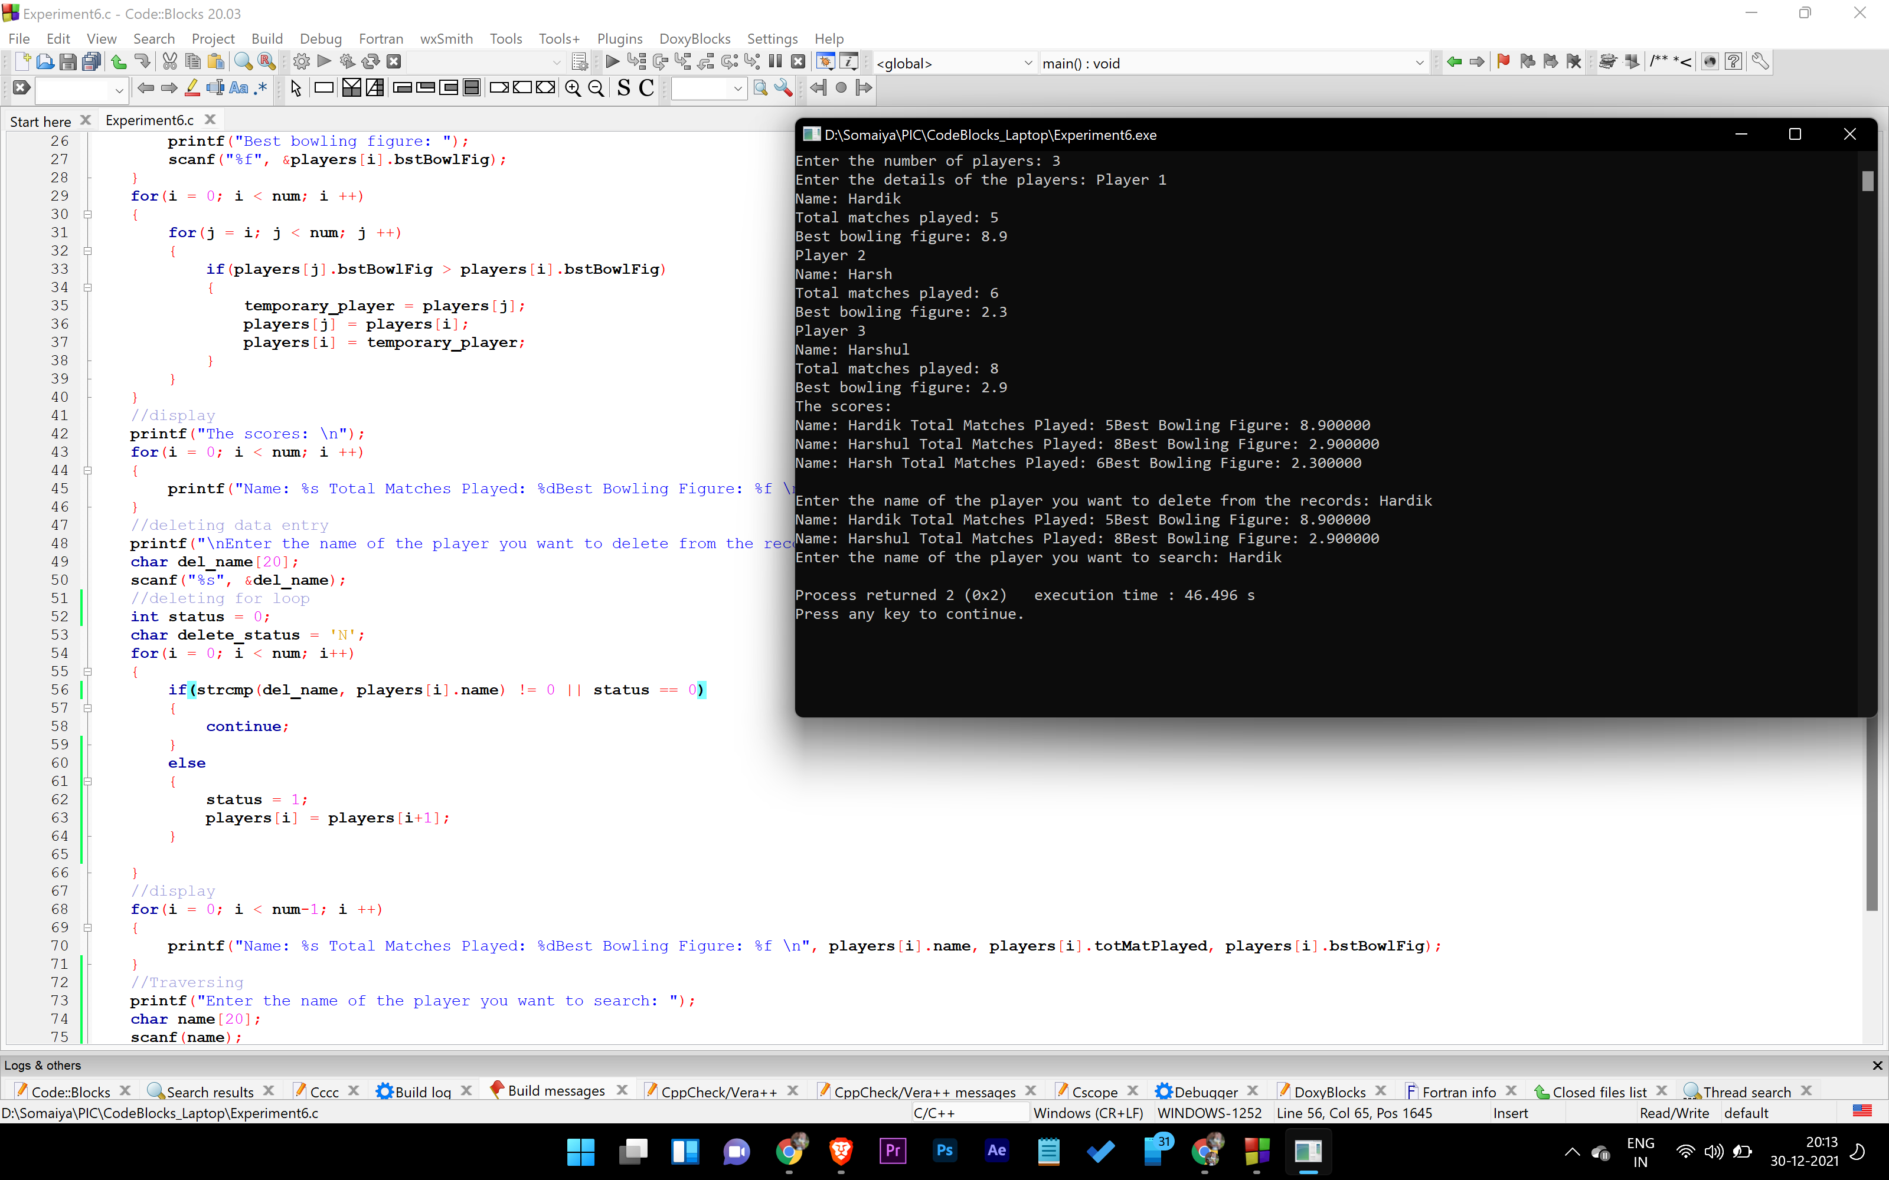

Conclusion:

With this experiment we learn how to traverse array data and even erase data of a player from array of structures.

Post Lab Descriptive Questions

- Comment on the output of the following C code.

#include <stdio.h>
struct temp
{
int a;
int b;
int c;
};
main()
{
struct temp p[] = {{1, 2, 3}, {4, 5, 6}, {7, 8, 9}};
}

Ans:
Error Line 8: invalid data type of method.

- Consider the following C code. What will be the output?

#include<stdio.h>
struct st
{
int x;
struct st next;
};

int main()
{
struct st temp;
temp.x = 10;
temp.next = temp;
printf("%d", temp.next.x);
return 0;
}

(A) Compiler Error
(B) 10
(C) Runtime Error
(D) Garbage Value

Ans:
- Compile Error
Reason: temp.next is a string so the value assigned to it must be mentioned in double inverted commas.

- Difference between Structure and Union.

Structure | Union
Keyword “struct” is used to define a structure. | Keyword “union” is used to define an union.
Indivisual member of a structure can be accessed at any time. | Only one member can be accessed at a time.
Structure members don’t share their memory. | Union members share by memory for other union members.

Date: _____________ Signature of faculty in-charge

